DIRTY COW
(CVE-2016-5195)
A Linux kernel Exploit

A Seminar Report

Submitted by

SUBHAJIT BARH
(18MA60R33)

in the partial fulfillment for the award of the degree
of

MASTER OF TECHNOLOGY
in
COMPUTER SCIENCE AND DATA PROCESSING
at


DEPARTMENT OF MATHEMATICS
INDIAN INSTITUTE OF TECHNOLOGY KHARAGPUR
WEST BENGAL-721302,INDIA

February 2019

ABSTRACT

Though Linux is lagging in the desktop user market(only 2.7 % user uses Linux according to a survey of November 2018 ) severs use Linux extensively. Around 80% servers use Linux as OS and popular mobile operating system like android also uses Linux kernel underneath it.
When in an operating system of that magnitude we found a security vulnerability it is really scary for all kind of reasons. Though Linux is in over all really a secure operating system than its counterparts but it also had its bad days.
2016 November was a nightmare for Linux developers because in that month Dirty COW(CVE-2016-5195) was discovered by a security researcher named Phil Oester. It was an Privilege Escalation Vulnerability and it utilized race condition to exploit an ancient flaw in the linux kernel. Linux Kernel version 2.6.22 (Released in 2007) to kernel 4.8.3 (in 2017) are vulnerable. Now Linus Torvalds the father of the Linux project said that he discovered it(the BUG) a long time ego and tried to fix it in vain he termed it as theoretical vulnerability. But it is not theoretical any more .
Linux Developers tried to fix the BUG in 2016 hurriedly but was not a complete success The patch was not full proof. In 2017 it was fully patched and it is Dirty COW free from Linux kernel 4.15(UBUNTU 18.04).
So staying updated is the only defense we have in this scenario. Thus in this seminar report I will try to explain what was the bug , how it was exploited and what we can do about it .

What is Dirty COW

Dirty COW is a privilege escalation type vulnerability .It is identified as CVE-2016-5195 .
It got CVE score of 7.2 which is pretty high . Any server running Linux kernel 2.6.22-4.8.* is vulnerable to this attack .It was Discovered by Phil Oester in 2016 and it existed almost 10 years before fully patched.

What is Privilege Escalation

Privilege Escalation or priv-esc is an attack(technique) through which an normal user can elevate or escalate his privilege .Earning root privilege can be a tedious job when it comes to security research.
But with Dirty COW it becomes easy and any script-kiddy can do it.

What is Race Condition:
Dirty COW is a race condition vulnerability. When Two process or two independent thread are running on the same resources it is impossible to say which job will occur first and which will occur second .so it is poorly sequenced. It is called race condition because two jobs are running for the same resource at the same time .Dirty COW leverages that situation .

Permission Systems in Linux:
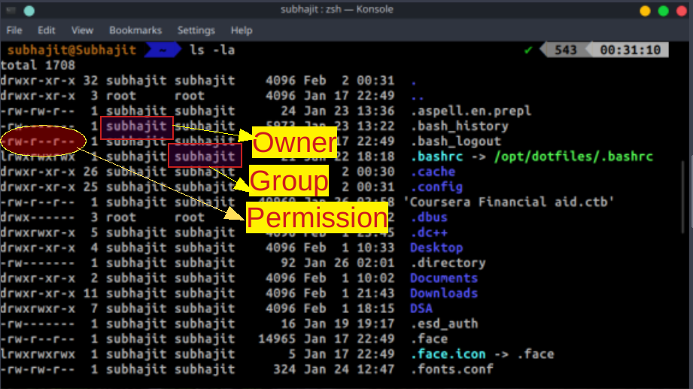
as shown in the figure 10 characters are used for permission in Linux
first character :‘-’ if its file and d if it is directory
Next 3 letters are permission for owner
- ‘r’ means read privilege
- ‘w’ means write privilege
- ‘x’ means execution privilege
Next 3 letters are for groups(same description)
Next 3 are for others
‘-’ means absent of permission
If ‘-’ is there in place of w that means it is write protected
‘root’ - is the Highest privilege in Linux

Root has all the permissions that is read write and execute .
We want to become root from normal users ....
Some times it is needed to run root commands despite being non root. for this there is a command called sudo (Superuser Do) which grants you temporary root privilege if you(user) are listed in sudoers(/etc/sudoers) file
What if you are not in sudoers file ?? can you gain root privilege ??Normally you can't. But you can take advantage of security loop-holes and escalate your privilege. That is called privilege escalation attack. There are many Priv-Esc methodologies .One of them is exploiting Kernel .It is Dangerous and unstable .But can grant you root privilege. Dirty Cow is an Kernel Exploit.

Linux Kernel :

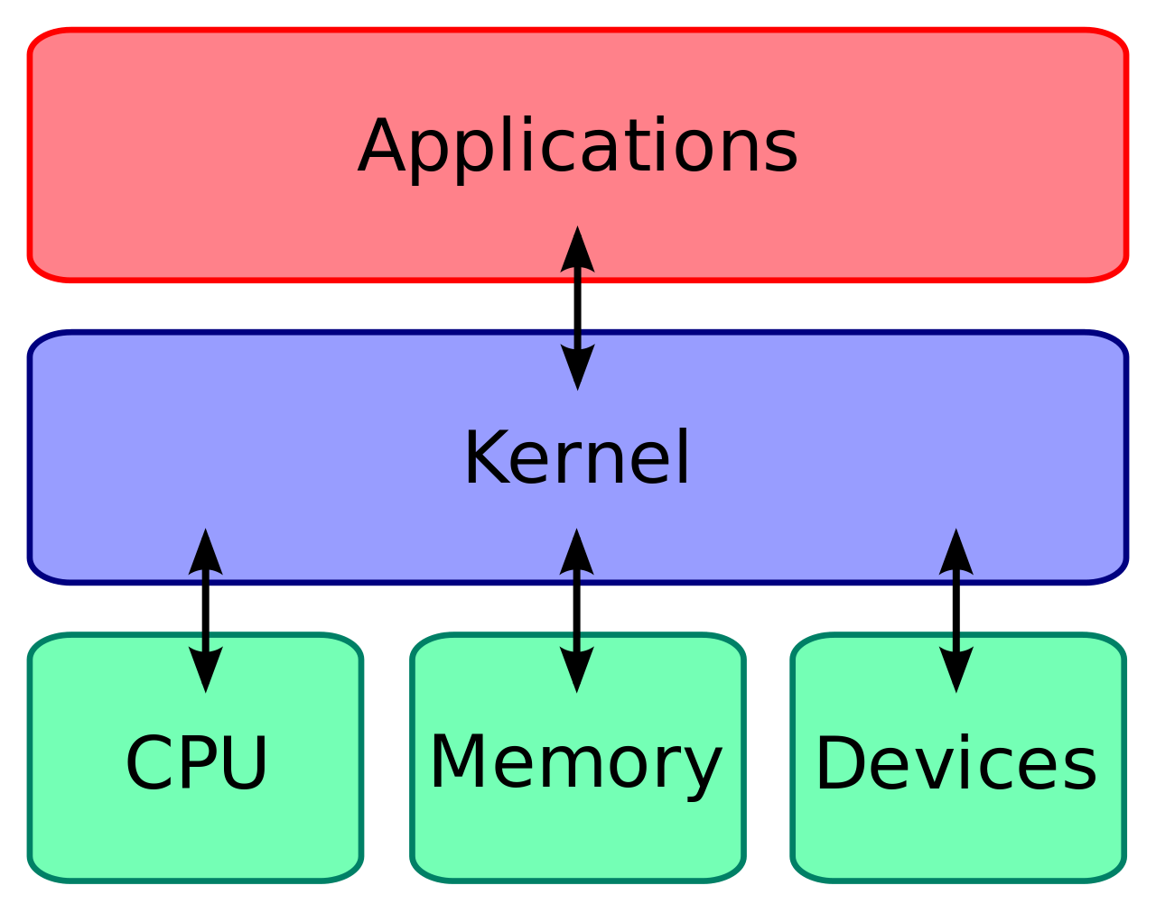
Kernel is the portion of Operating System through which applications can communicate with hard ware. In a way kernel is the core of the Operating System .
Linux Kernel is open source that means any body can contribute to it. It was created by Linus Torvalds . And is almost written in c , Linux is an monolithic kernel and follows posix standard.
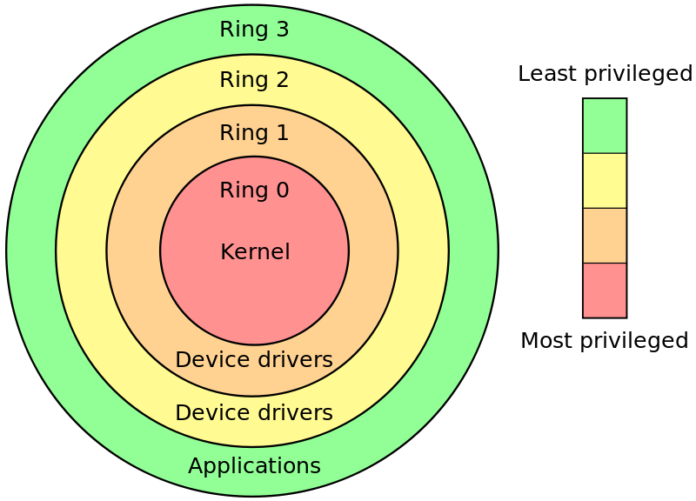
This is the popular CPU ring diagram .It shows us how Linux kernel and CPU are related and various abstraction layers. Generally Deeper You go more privileged You are .Linux and most other operating Systems generally uses kernel ring 0 and ring 3 . Generally ring 2 and 3 are not used but software like virtual Box and container application like docker uses ring 2 and 3 .
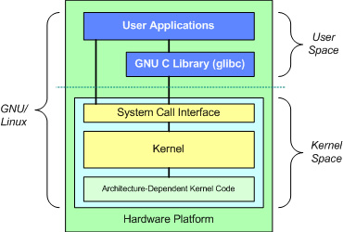
ring 3 can not have privilege of ring 0 that is it can not control hardware .But then how software communicates with the hardware ? Answer is System Calls or Sys-Calls they are special kernel functions that can be called by applications to communicate with hardware .

In Linux User memory space and Kernel memory space is different .Users memory space is managed by paging and virtual memory management .and kernel memory space is separate and secured . So we communicate with them only through Sys-Calls . In our case there is a security loop hole in the Linux secure code that we will exploit .

Paging:

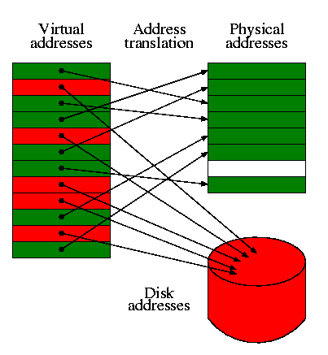
The above picture nicely explains what is paging and virtual memory .
Operating System always want to give any program a continuous memory space . But that is not possible when we have multiple Program Running .There is two methods used to handle this problem one is segmentation another is paging .Here we will talk about paging .
In paging the computer will divide the physical memory into various fixed size(in Linux x64 architecture 4kb) pieces called frames .those are called frames . Now in the program we divide it into several piece also it is called pages . Frame size = page size . Now collection of pages of any particular program is called virtual memory .Now in Linux memory is also can be accessed like file
files .that file is proc/self/mem . Here self is because it will access its own memory as we will see later .this is called out of band memory access . Page table is the table is a translation table which maps physical memory into virtual memory . So it stores page address .

Page fault:
What happens when cpu can not find a physical memory page corresponding to virtual memory?
May be the memory have been swapped to secondary storage ....
MMU can not find the associated page in page table ...
It initiates a page fault trap interrupt .
The page fault handler in the operating system makes an entry for the page in the page table and hands the control to the MMU .
Page Fault can be Hard Fault or Soft Fault .
Soft faults are Common and happens when page is present in the physical memory but just there is no entry in page table for that. CPU finds that memory and and makes entry in page table and hands over control to the main process .
Hard fault is when page has been swapped in the Hard Disk and CPU need to fetch it from the hard disk to main memory . As Hard Disk is slow it reduces the performance and this phenomenon is called thrashing.

Copy On Write(COW):

- When want to write on any write protected file which is now mapped to the memory Kernel creates a copy of it and writes on it(Copy On Write) .
- It is done by using some flags one of them is foll_write(important one for this presentation).
- If file is not write protected then foll_write is not set and CPU writes the changes to the original mapping of the file.
- Now the original user memory page becomes touched or Dirty .
- Now if any pages are dirty then it will be written on the disk by the CPU.
- What happen when CPU initiates a COW page but does not find it .
- Definitely a page fault happens and the vulnerability lies in how kernel resolves the fault.
- But How we force the page fault in that exact time ?
- We will See .......

Dirty Bits:

A dirty bit or modified bit is a bit that is associated with a block of computer memory and indicates whether or not the corresponding block of memory has been modified.The dirty bit is set when the processor writes to (modifies) this memory. The bit indicates that its associated block of memory has been modified and has not been saved to storage yet. When a block of memory is to be replaced, its corresponding dirty bit is checked to see if the block needs to be written back to secondary memory before being replaced or if it can simply be removed. Dirty bits are used by the CPU cache and in the page replacement algorithms of an operating system.

